 [Translated from Chinese (Simplified) to English - www.onlinedoctranslator.com](https://www.onlinedoctranslator.com/en/?utm_source=onlinedoctranslator&utm_medium=docx&utm_campaign=attribution" \o "Doc Translator - www.onlinedoctranslator.com)

**USB to M-Bus master station instruction manual**

**Lingchuang Electronic Technologylimited company**

07/17/2020

Table of contents

1. overview 3

1.1 Introduction 3

1.2 Features 3

2. performance parameters 4

2.1 Performance parameters 4

3. Function and Operation 4

3.1 Function Description 4

3.2 Overload Protection and Tips 5

4. Frequently Asked Questions and Answers 5

# overview

## 1.1 Introduction

M-Bus (Meter Bus) is an instrument bus, which is a bus specially designed for consumption measuring instruments (such as water meters, heat meters and gas meter series) and counters to transmit data, the purpose is to meet the needs of network systems and remote meter reading . M-Bus consists of a master station, several slave stations and a pair of connecting cables. All slave stations are connected to the bus in parallel, and the master station controls all serial communication processes on the bus. The master station regularly reads the data of the slave station, and when the slave station receives a data transmission request, it sends the currently measured data to the master station.

This USB to M-Bus master station is composed of a serial communication module, a power module, a modem module, an indication module and a protection module. The power supply module takes power directly from the USB port without additional power input; the modulation and demodulation module is independently developed, with strong load capacity, good receiving performance, and high communication speed; the indication prompt module indicates the power status of the master station and the status of data transmission and reception, and prompts the bus Short circuit and overload: The protection protection module protects the USB port of the computer from being damaged when accidents such as overvoltage, overcurrent, and M-Bus current backflow occur, and at the same time protects the master station from being damaged when the bus is touched by short circuit, overload, or electrostatic shock. damage. The USB to M-Bus master itself consumes less than 25mA, and is small in size, easy to carry and use.

## 1.2features

* Standardized design: comply with European EN1434-3 standard, Chinese CJ/T188-2018 standard
* No need for external power supply: USB port provides direct power supply, no need to add additional power supply
* Low power consumption: no-load state, current consumption ≤ 25mA
* Strong loading capacity: can carry 20 slave stations
* Good receiving performance: a large number of consecutive 0x00 bytes can be completely received without data loss
* High communication rate: the baud rate supports up to 115200bps
* More comprehensive protection: USB port overvoltage, overcurrent protection, M-Bus short circuit, overload protection, ESD protection
* More comprehensive indication: power light indication, sending light indication, receiving light indication, overload sound prompt
* Connection non-polarity: When the slave station is connected to the bus, there is no need to consider the polarity of the two M-Bus lines, just merge them
* Small size: 84.5mm*45.0mm*25.5mm.

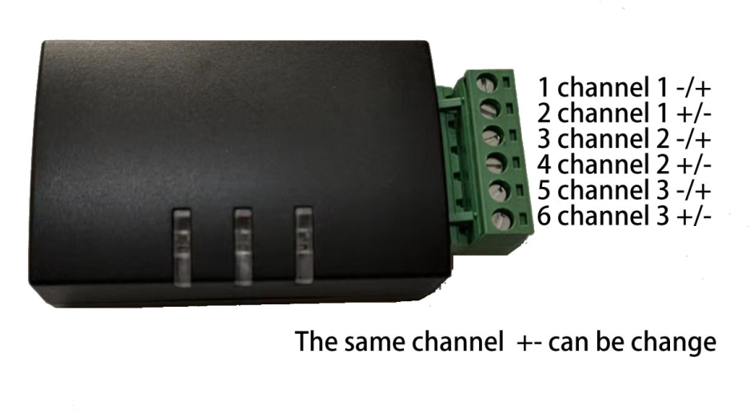

# performance parameters

## 2.1 Performance parameters

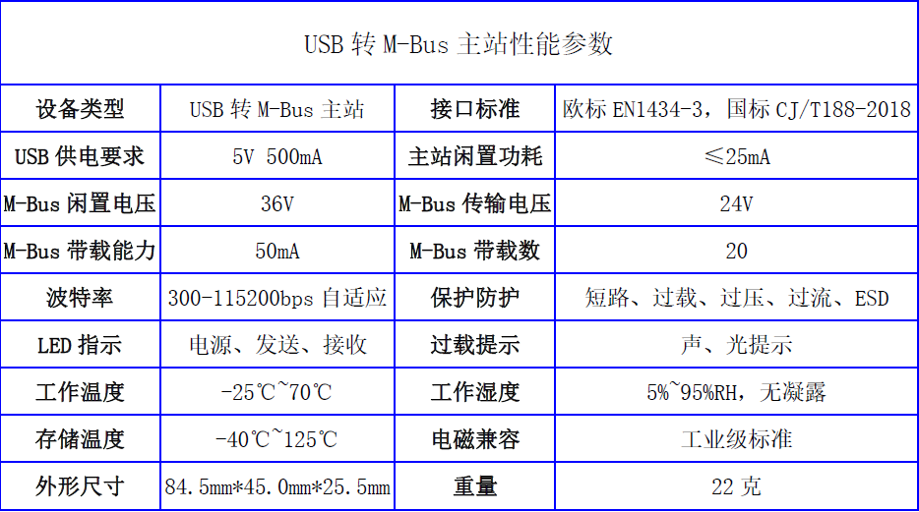

# Function and Operation

## Function Description

|  |  |
| --- | --- |
| USBinterface | * It is both a power port and a communication port; * Power supply voltage 5V, current 500mA; * The main station has overvoltage protection and overcurrent protection inside. |
| m-BUSinterface | * M-BUSThere are two or three groups of interfaces (random delivery from the warehouse), MBUSNo distinction between positive and negative polarity, 1 and 2 a group, 3 and 4 a group, 5 and 6 a group (only three groups of interfaces are satisfied) * The bus voltage is 36V when idle, the bus voltage is 24V when transmitting, and the load capacity is 50mA; * With short circuit protection, overload protection |
| indicator light | * Power light: Indicates the status of the USB power supply, the light is on when the power supply is normal, otherwise the light is off: * Sending light: Indicates the data sending status, the light is on when sending data, otherwise the light is off: * Receiving light: Indicates the data receiving status, the light is on when receiving data, otherwise the light is off |
| buzzer | * When the M-Bus is short-circuited or overloaded, the buzzer will send out a "beep" sound. |

## 3.2 Overload Protection and Tips

* Short-circuit protection: During the use of the M-Bus, it is inevitable that there will be a short-circuit by touching. In view of this situation, the master station adds a short-circuit protection function, and enters the overload protection state within 100ns of the short-circuit, disconnecting the bus.
* Overload protection: The maximum load current of the master station is 50mA, if the load current exceeds 50mA continuously for 100ms, the master station enters the overload protection state and disconnects the bus.
* Overload release: After the master station enters the overload protection state, try to connect to the bus at an interval of 500ms. If the overload still exists, enter the overload protection state again and disconnect the bus: if the overload has been released, the master station enters the normal state and connects to the bus.
* Overload reminder: When overload occurs, the buzzer will emit a "beep" sound to prompt, and the receiving light will flash once; if the overload still exists, the buzzer will periodically emit a "beep" sound at an interval of 500ms, and the receiving light will be accompanied by a "beep" sound flashing.

# Frequently Asked Questions and Answers

* Problem 1: The power light is off.
* answer:

1. Check whether the USB port of the computer is powered;

2. Check whether there is poor contact between the computer USB port, the master station USB port and the USB cable:

3. Check whether the USB cable is disconnected.

* Question 2: The sending and receiving indicators are not on when copying.
* answer:

1. When the amount of data is small or the baud rate is high, the communication time is short, and the sending and receiving indicators flash and go off, which is difficult for human eyes to detect;

2. Check whether the port is selected correctly and whether the driver is installed successfully;

* Question 3: When reading, the sending indicator light is on, but the receiving indicator light is off.
* answer:

1. Check whether the M-Bus lines of the master station and the slave station are connected correctly;

2. The slave station does not respond to the reading data frame sent by the master station, and should check whether the serial port parameters and data frame are adapted by the slave station;

* Question 4: I have been copying normally before, but suddenly there is no response to copying
* answer:

1. Check whether there is poor contact between the USB port of the computer, the USB port of the master station and the USB cable;

2. You can close the serial port and open it again to test whether the reading is normal.

* Question 5: None of the above answers can solve your problem.
* answer:

1. Please check whether the USB to M-Bus master station is damaged due to problems such as wrong connection, high voltage, disassembly, and transformation;

2. Please contact the manufacturer for repair or return.